**Ventoy Presistance Mode on kali linux and parrot os**

This article was written using Google YouTube and AI tools: chatgpt, perplexity

**What burning iso to diskonkey means**

Burning an ISO to a diskonkey usb just means your unpacking it (opening it and copying it over) to your USB.  
sources  
<https://www.reddit.com/r/linux4noobs/comments/7xi6n0/what_does_burning_an_iso_do_to_my_usb/>  
<https://superuser.com/questions/429228/why-is-an-iso-file-needed-to-burn-into-a-usb>  
<https://ubuntuforums.org/showthread.php?t=1762951>

**What is ventoy**

Ventoy is an open source tool to create bootable USB drive for ISO/WIM/IMG/VHD(x)/EFI files

<https://www.ventoy.net/en/index.html>

Ventoy burn on diskonkie download

<https://www.ventoy.net/en/download.html>

OS:

Kali linux live usb download  
<https://www.kali.org/get-kali/#kali-live>

Parrot os download  
<https://parrotsec.org/download/>

Before you connect your ventoy diskonkey you need to disable secure boot in your pc bios

**What is USB persistence mode**

The persistence allows you to keep your preferences and data even after reboot.  
The Data saved in this reserved space won’t be deleted when you shut down the live session. The next time you boot into the live session, you are still able to access and retrieve the data.  
sources  
<https://www.linuxliveusb.com/en/help/faq/persistence/67-what-is-persistence#:~:text=The%20persistence%20allows%20you%20to%20keep%20your%20preferences,is%20a%20completely%20transparent%20process%20for%20the%20user>  
<https://www.maketecheasier.com/persistent-live-usb-vs-full-install-usb/>

**what is persistence.dat partition in ventoy**

according to perplexity:

In Ventoy, persistence.dat is not a partition but a file used to enable persistence for live Linux distributions. It allows users to save changes made during a live session, preserving them for future use

<https://forum.garudalinux.org/t/ventoy-persistence-plugin/33961>

<https://www.ventoy.net/en/plugin_persistence.html>

**what is plpbt.iso for virtual machines**

plpbt.iso is a crucial tool for enabling USB boot functionality in virtual machines, particularly in VMware and VirtualBox, which do not natively support booting from USB devices

This ISO file contains the Plop Boot Manager, a small software that allows users to boot from USB drives in environments where BIOS support for USB booting is lacking

<https://www.oueta.com/virtualbox/boot-from-usb-flash-drive-without-bios-support-via-plop-boot-manager-tested-on-virtualbox/>

<https://www.geekyprojects.com/virtualization/how-to-boot-from-usb-in-vmware/>

<https://theholyjava.wordpress.com/2010/06/10/booting-from-a-usb-stick-in-vmware-player/>

<https://www.plop.at/en/bootmanager/intro.html>

**How to create** **persistence mode partition in ventoy** **on usb for kali linux and parrot os**

According to chatgpt:

Ventoy persistence mode giude from https://chatgpt.com/

This guide explains how to configure Ventoy with persistence for Kali Linux and Parrot OS, including the creation of JSON configuration files for both command-line interface (CLI) and graphical user interface (GUI) setups.

Prerequisites

1. Hardware and Software Requirements:

USB drive with at least 16GB of storage (recommended 32GB or more).

ISO files:

♣ Kali Linux ISO

<https://www.kali.org/get-kali/#kali-live>

♣ Parrot OS ISO

<https://parrotsec.org/docs/introduction/download-parrot/>

<https://parrotsec.org/download/>

Ventoy software (Download from the official site).

<https://www.ventoy.net/en/download.html>

2. Persistence Compatibility: Ventoy supports persistence mode for most Linux distributions, including:

Kali Linux: Officially supported.

Parrot OS: Officially supported.

Step 1: Install Ventoy on the USB Drive

1. Download Ventoy:

Visit the official Ventoy website and download the latest release.

<https://www.ventoy.net/en/download.html>

2. Install Ventoy:

Extract the downloaded file and run the appropriate installer:

♣ Windows: Ventoy2Disk.exe

♣ Linux: Ventoy2Disk.sh

Select your USB drive and click Install.

♣ Warning: This will erase all data on the USB drive.

After installation, the USB drive will have a Ventoy partition.

Step 2: Add ISO Files to the USB Drive

1. Copy the Kali Linux and Parrot OS ISO files directly to the root of the USB drive.

2. Ensure the ISO files have descriptive names (e.g., kali-linux.iso, parrot-os.iso).

Step 3 create folders for persistence and config files inside the USB Drive

For persistence file create persistence folder

For config file create ventoy folder

Addition you can create an iso folder and put there your iso files

Step 4: Enable Persistence for Each ISO

Creating a Persistence File

Persistence files store changes made during the live session. Follow these steps to create persistence files:

1. Using Ventoy Script (Recommended for Linux Users):

Download the persistence creation script from the Ventoy Persistence Plugin documentation.

<https://ventoy.net/en/plugin_persistence.html>

on linux run the script: sh CreatePersistentImg.sh [ -s SIZE_IN_MB ] [ -t FSTYPE ] [ -l LABEL ] [ -c CFG ]

meaning of options/flags

**-s SIZE_IN_MB**: Specifies the size of the image in megabytes.

**-t FSTYPE**: Defines the file system type for the image (e.g., ext4, xfs).

**-l LABEL**: Sets a label for the image (a name or identifier).

**-c CFG**: Likely specifies a configuration file or settings for creating the image.

Run the script in a terminal:

sh ./create_persistence_img.sh -s 4096

Replace 4096 with the desired size in MB for the persistence file.

This will generate a persistence.dat file.

2. You can also download this presistanse files from githab:

<https://github.com/ventoy/backend/releases>

for kali linux and parrot os persistence.dat work for me

copy persistence.dat 2 times to the USB and change its name for easy identification

3. Save the persistence.dat file in the /ventoy directory on your USB drive.

Create a JSON Configuration File

Ventoy uses a ventoy.json file to configure persistence. The file should be placed in the /ventoy directory on the USB drive.

CLI Example

Below is a sample JSON file for enabling persistence for Kali Linux and Parrot OS:

{

"persistence": [

{

"image": "/kali-linux.iso",

"backend": "/ventoy/kali-persistence.dat"

},

{

"image": "/parrot-os.iso",

"backend": "/ventoy/parrot-persistence.dat"

}

]

}

GUI Example

If using a Ventoy configuration GUI tool (e.g., VentoyPlugson):

1. Launch the tool and select your Ventoy USB drive.

2. Click Add Persistence Plugin.

3. For each ISO:

Set the ISO path (e.g., /kali-linux.iso).

Set the persistence file path (e.g., /ventoy/kali-persistence.dat).

4. Save the configuration, which will generate a ventoy.json file.

I use windows os so the Ventoy configuration GUI tool is VentoyPlugson.exe



Then a popup open ask you to run ventoy service

Click start to start ventoy service

Click stop to stop ventoy service

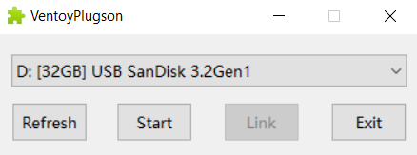

תמונה שמכילה טקסט, גופן, מספר, קו

תוכן שנוצר על-ידי בינה מלאכותית עשוי להיות שגוי.

A website open on your browser

Navigate to persistence plugin

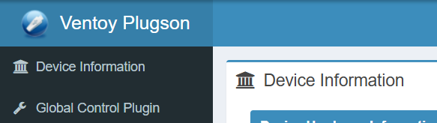

תמונה שמכילה טקסט, גופן, צילום מסך, גרפיקה

תוכן שנוצר על-ידי בינה מלאכותית עשוי להיות שגוי.

Click add to create or add a configuration file



Click delete to delete a configuration file



After you click add a window open up

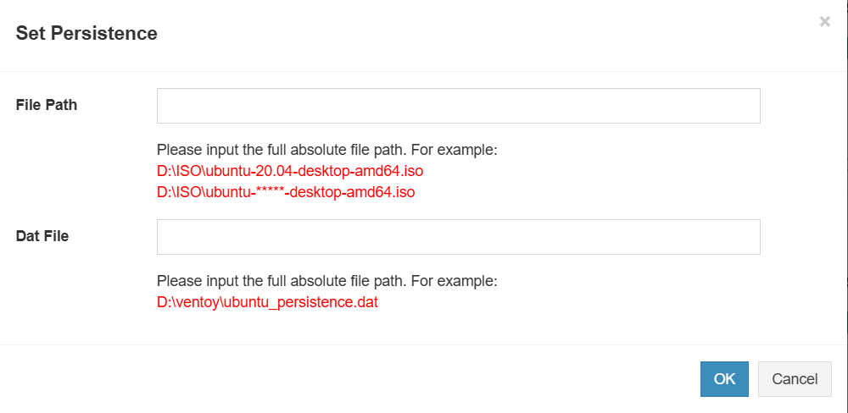

On **File Path** you navigate to iso file

On **Dat File** you navigate presistance.dat file

Then click ok

After this you see on the USB inside ventoy folder a ventoy.json file

Now you can exit the ventoy browser window and stop the ventoy service

When you stop the ventoy service the ventoy browser window will close

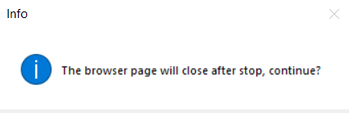

Click yes

תמונה שמכילה טקסט, צילום מסך, גופן, עיצוב

תוכן שנוצר על-ידי בינה מלאכותית עשוי להיות שגוי.

Click ok

Step 5: Boot and Test Persistence

1. Reboot your system and boot from the USB drive.

2. Select Kali Linux or Parrot OS from the Ventoy menu.

3. Choose the Persistence Mode option (if available).

4. Make changes in the live environment (e.g., create files, install software).

5. Reboot and confirm that the changes persist.

Kali linux:

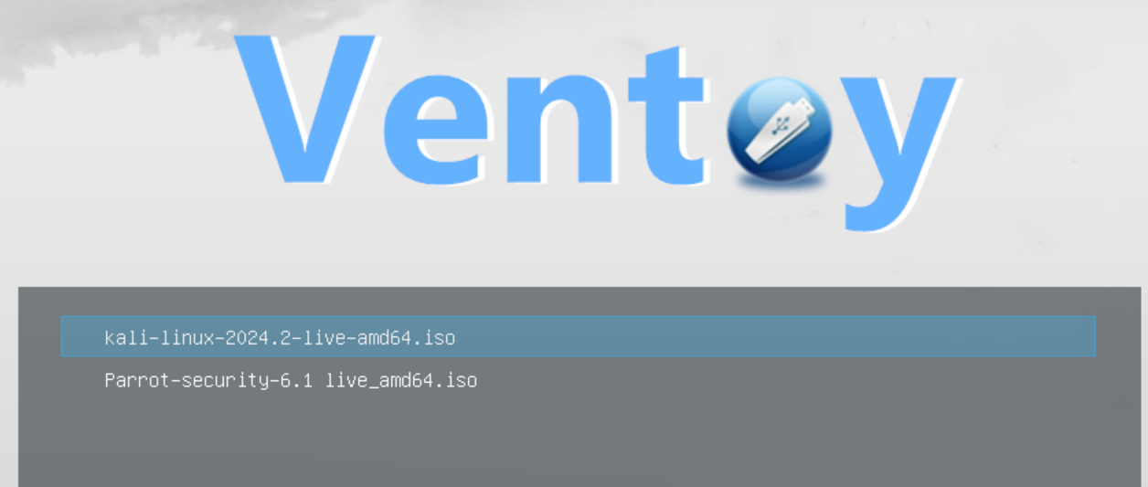

I choose kali linux

After this I choose Boot normal mode 1

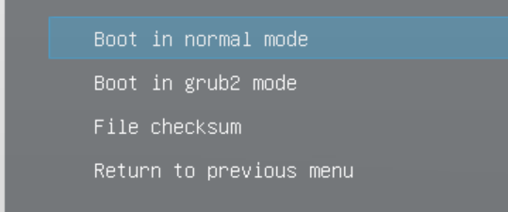

After this I choose Boot with presistance.dat



Then it start kali linux and you choose kali linux persistence mode

Called: Live system with USB persistence

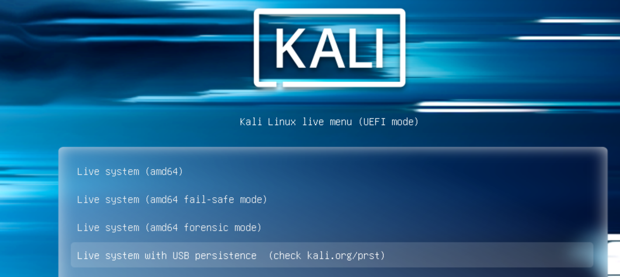



Then you enter kali linux and the changes you make will save inside persistence partition

Next time you enter kali linux persistence mode you see these changes

Parrot os:

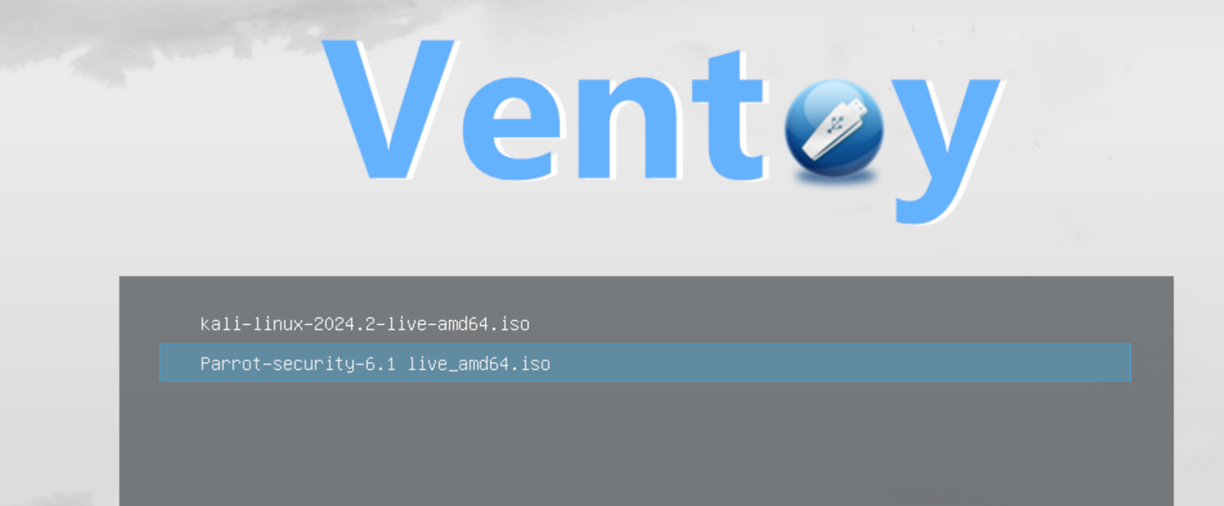

I choose parrot os

After this I choose Boot normal mode 1

תמונה שמכילה טקסט, צילום מסך, גופן

תוכן שנוצר על-ידי בינה מלאכותית עשוי להיות שגוי.

After this I choose Boot with presistance.dat

תמונה שמכילה טקסט, צילום מסך, גופן, עיצוב

תוכן שנוצר על-ידי בינה מלאכותית עשוי להיות שגוי.

Then it start parrot os and you choose advanced modes then choose persistence mode

Called: Persistence (need configuration)

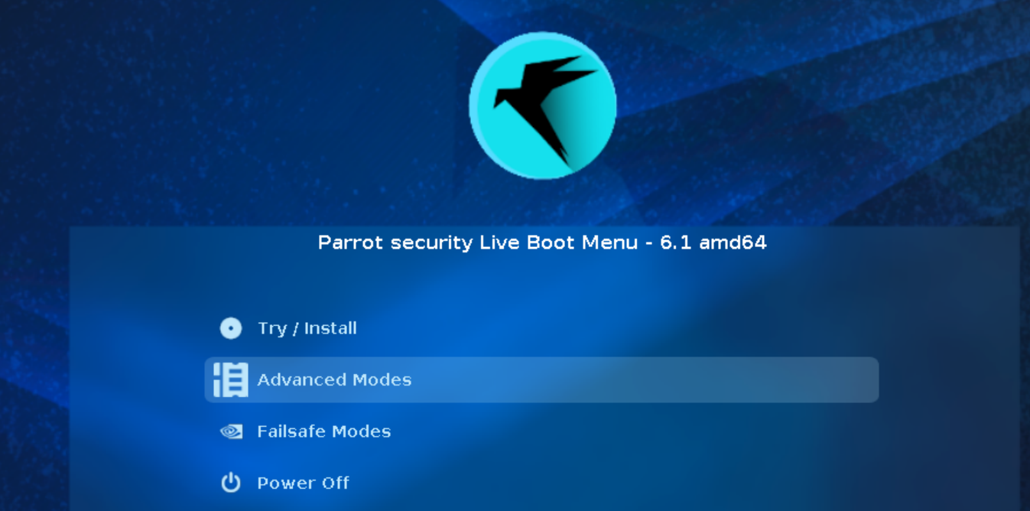



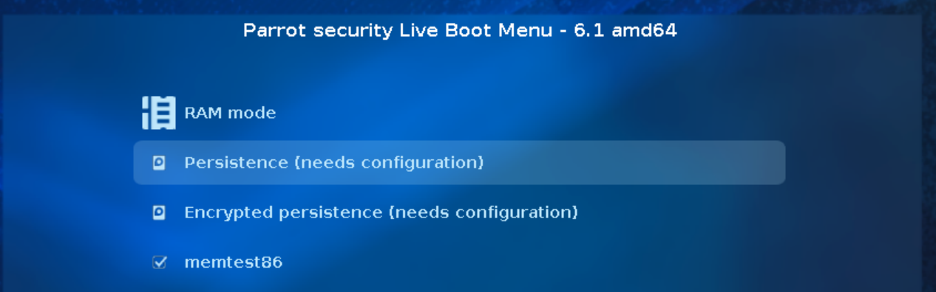



Then you enter parrot os and the changes you make will save inside persistence partition

Next time you enter parrot os persistence mode you see these changes

I boot my virtual machine using my ventoy usb and use plpbt.iso as a iso file and connect my ventoy usb to my virtual machine

After this I start my virtual machine and choose usb then I saw the ventoy start

plpbt.iso download from <https://www.plop.at/en/bootmanager/download.html>

**why presistance.dat work with parrot os on ventoy usb?**

According to chatgpt:

The persistence.dat file works with Parrot OS on a Ventoy USB drive because it enables persistent storage on a live USB setup

presistance.dat work with Debian destructions

<https://www.youtube.com/watch?v=qHe6hDXf0Og&t=241s>

**why persistence.dat work with parrot os on ventoy usb?** There are several types of persistence casper-rw.dat persistence.dat MX-Persist.dat vtoycow.dat Why does persistence.dat work with parrot os Search the internet and give me evidence of what you find, for example articles, videos and links to them

According to perplexity

Parrot OS uses persistence.dat as its persistence file for several reasons: Parrot OS is based on Debian, and therefore uses Debian's persistence system called "persistence"

<https://www.reddit.com/r/Ventoy/comments/1i9t7k5/parrot_os_linux_with_persistence_using_ventoy/>

**video to install linux os with presistance mode using ventoy**

<https://www.youtube.com/watch?reload=9&list=TLGGtdnzWc1g0wYwNDAzMjAyNQ&v=vJ8TMSZwo0I&embeds_referring_euri=https%3A%2F%2Fnotebooklm.google.com%2F>

<https://www.youtube.com/watch?v=qHe6hDXf0Og&t=241s>

<https://www.youtube.com/watch?v=sZP57jT45MY&t=248s>

**ai websites**

chatgpt: <https://chatgpt.com/>

perplexity: <https://www.perplexity.ai/>